Computer Networks Labsheet3

Introduction to Packet Tracer Simulator Labsheet3

Part2 – Connect a Wired and Wireless LAN
Download and complete the Packet Tracer Activity file from 4.6.5 and place it in a new folder created with this nomenclature having your name followed by your roll number Name_AA.SC.U3BCA2107xxx
Answer the following questions and finally add the screenshot with specified format having 100% completion.
- List the end devices in the logical topology.
- List the intermediary devices in the logical topology.
- How many different networks are available?
- How many different types of media connections are used in this network topology? Name them
- What are the cables seen for the Primary Network in the Physical view (Shift +P)?
- Primary network includes which networking device in the logical view (Shift+L) and what are the cables used for that networking device?
- Secondary network includes which networking device in the logical view (Shift+L) and what are the cables used for that networking device?
- Home network includes which networking device in the logical view (Shift+L) and what are the cables used for that networking device?
- Family-PC source End device requests home page (http://netacad.pka) from netacad.pka server destination end device. Try to figure out the path of the packet traversing from the source to the destination and provide proper screenshots.
Note: Try to take screenshots of completed Packet Tracer activity(pka) showing 100% completion. Always try to take screenshots of pka having your name and and roll number in this format Name_AA.SC.P2MCA2107xxx as identity in the title bar along with the completion status as shown below.
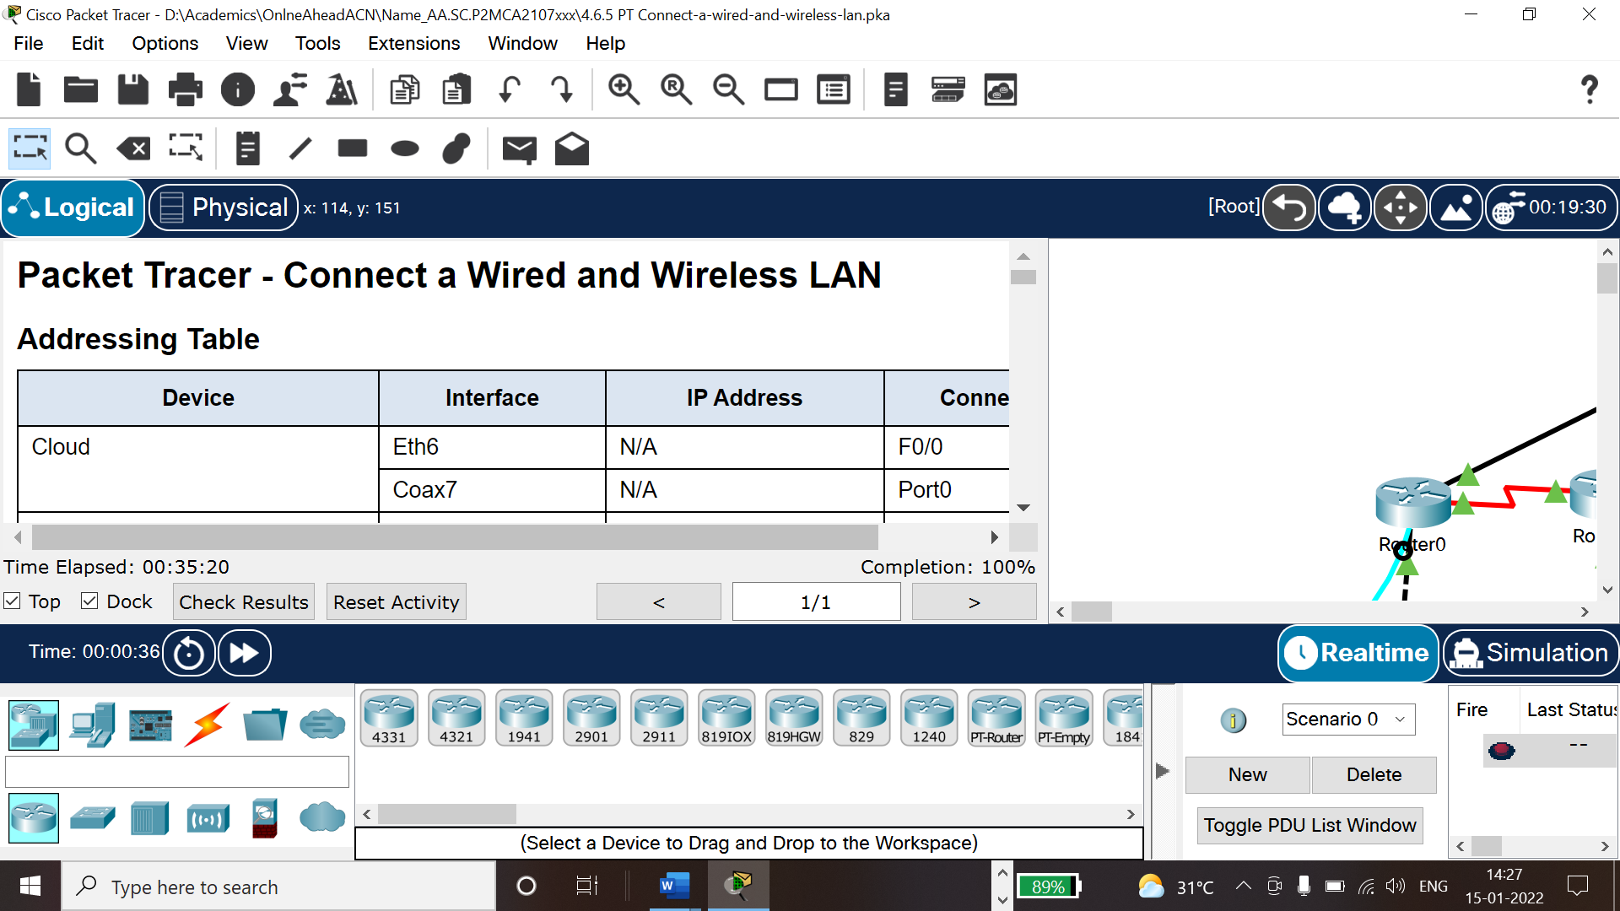

Optional:
Try to submit the screenshot having 100% completed packet tracer activity for 4.7.1_PT_Connect_the_physical_layer.pka

